Hazard: Various injuries | 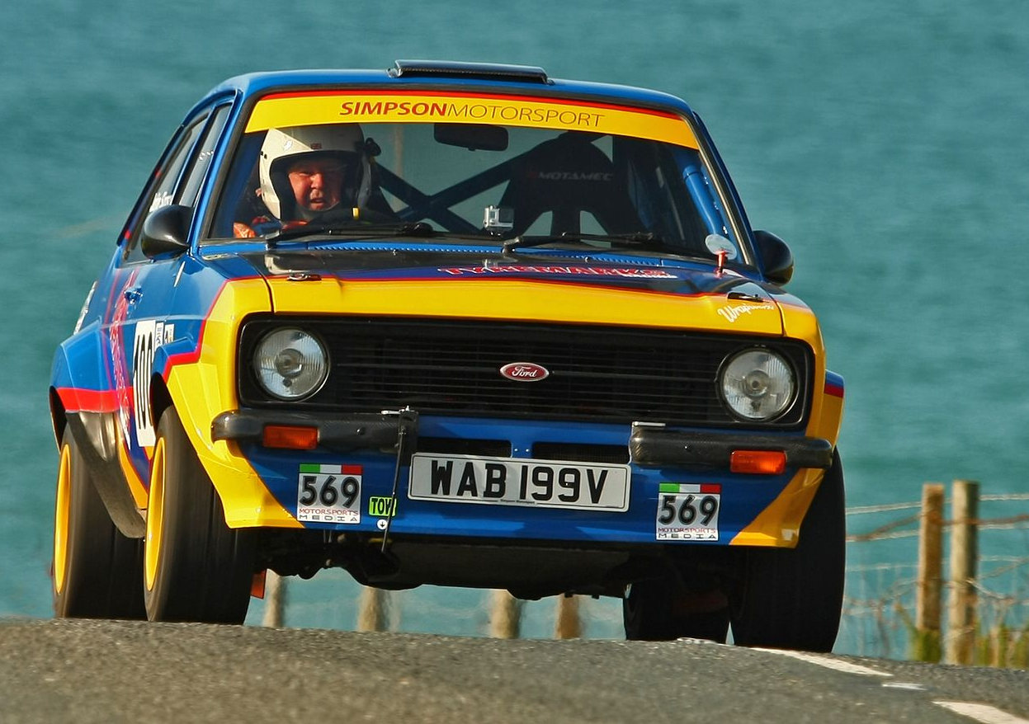
Associated With: Motorsport Photography - circuit racing, sprints, hill climbs and stage rallies including tests days and demo’s.

Who is at Risk: Photographers and assigned media assistants, spectators and event officials.
Risk with no Controls in place
Low | Moderate | High | Intolerable
 | x

Risk of:
- Trips, slips and Falls
- Impact with stationary and moving objects including vehicles and track side equipment (cones, bales, signs)
- Impact with debris thrown from vehicles (rocks, stones, dust)
- Injuries associated with weather, hot and cold conditions (heat exhaustion, frost bite, hyperthermia)
- Damage to hearing

Assessment

 |  | Probability
 |  | A Frequent | B Probable | C Occasional | D Remote | E Improbable
Potential Severity | 5 Major |  |  |  | X
 | 4 Serious |  |  |  | X
 | 3 Moderate |  |  |  | X
 | 2 Minor |  | X | X
 | 1 Negligible |  |  | X
 | 0 None

Controls;

- (5D) Photographers are to assess each location for safety, stand on firm and level ground.
- (5D) Photographers should not stand in escape roads or areas marked as prohibited.
- (4D) Photographers should not stand trackside or on stage roads unless under control of marshals or supporting appointed medical staff.
- (2B) Photographers should wear warm/wet weather clothing appropriate to the conditions including boots whilst walking to/from locations.
- (1C) Carry Food and Drink and stay hydrated.
- (1C) Use sun cream and consider appropriate shade to avoid heat stroke
- (1C) Consider use of ear protection
- (3D) Only used pre-designated locations for photography
- Follow the Motorsport UK code of practice.
- Follow guidelines IAW - Motorsport UK stage rally marshal training
- Wear PPE as per list below including Motorsport UK media tabards
- Be identified with official Motorsport UK level 2 media ID

Work Equipment and PPE Required:
Media Tabards, Lanyard ID, Walking Boots, Cold weather clothing, Sun Cream

Risk with Controls in Place
Low | Moderate | High | Intolerable
X

Health Surveillance

Type | Tick Box | Type | Tick Box
Lung Function  Skin Exposure / Dermatitis  Hearing  Hand Arm Vibration  Eye Sight |  | Lead  Blood / Content  Urine Sampling  Radiation  General Fitness

Indicate Frequency of Health Surveillance
Annually  Biannually |  | Quarterly  Monthly

569 Media - Operational Management must ensure that any indicated Health Surveillance is implemented and scheduled.

